PRACTICAL – 3
Design responsive layouts for Home, About, Registration, Dashboard, and Events pages using CSS Grid and Flexbox. Optional to use CSS framework such as Bootstrap or Tailwind. Ensure mobile-first responsiveness.

The objective of this practical is to design responsive user interface layouts for the StudentHub website. The pages designed include Home, About, Registration, Dashboard, and Events. The layouts should work properly on mobile phones, tablets, and desktop computers.

CSS Grid and Flexbox are used to arrange the content in an organized and flexible manner. Responsive design ensures that the website is easy to use and readable on different screen sizes.

Login page:
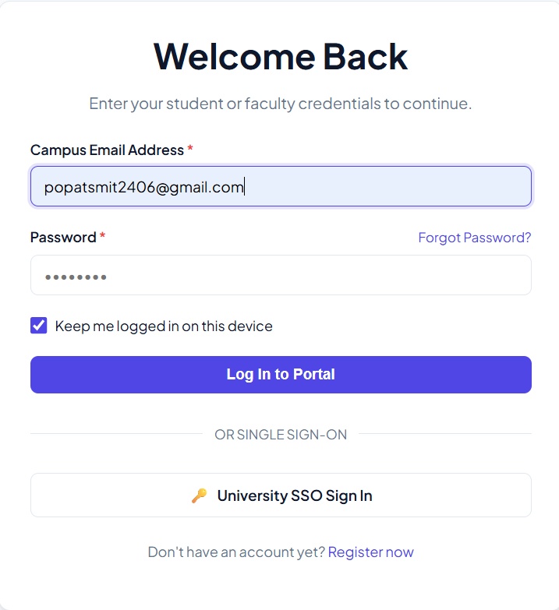

Register Page:
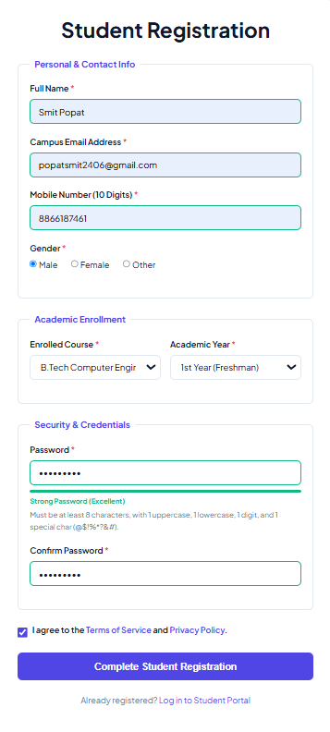

Dashboard Page:
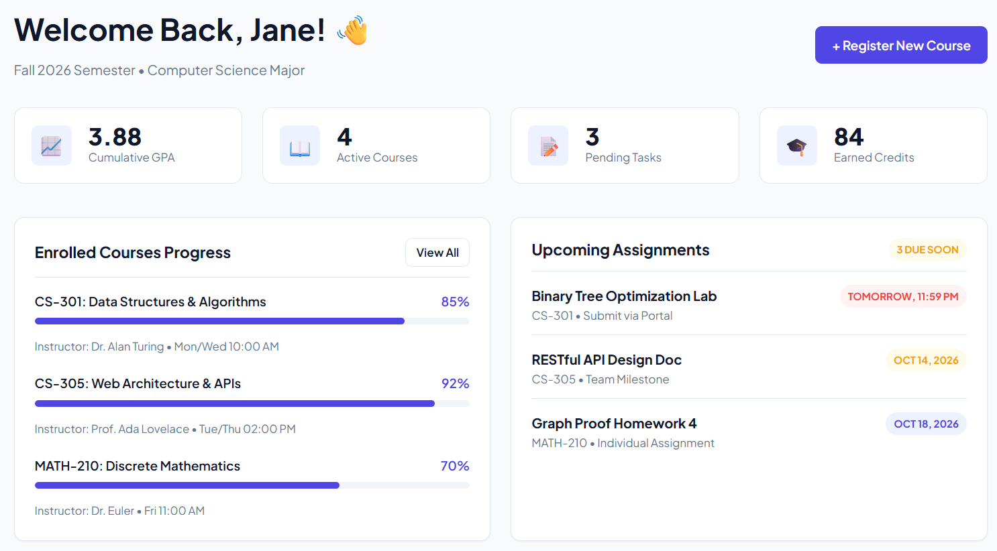

Contact Page:
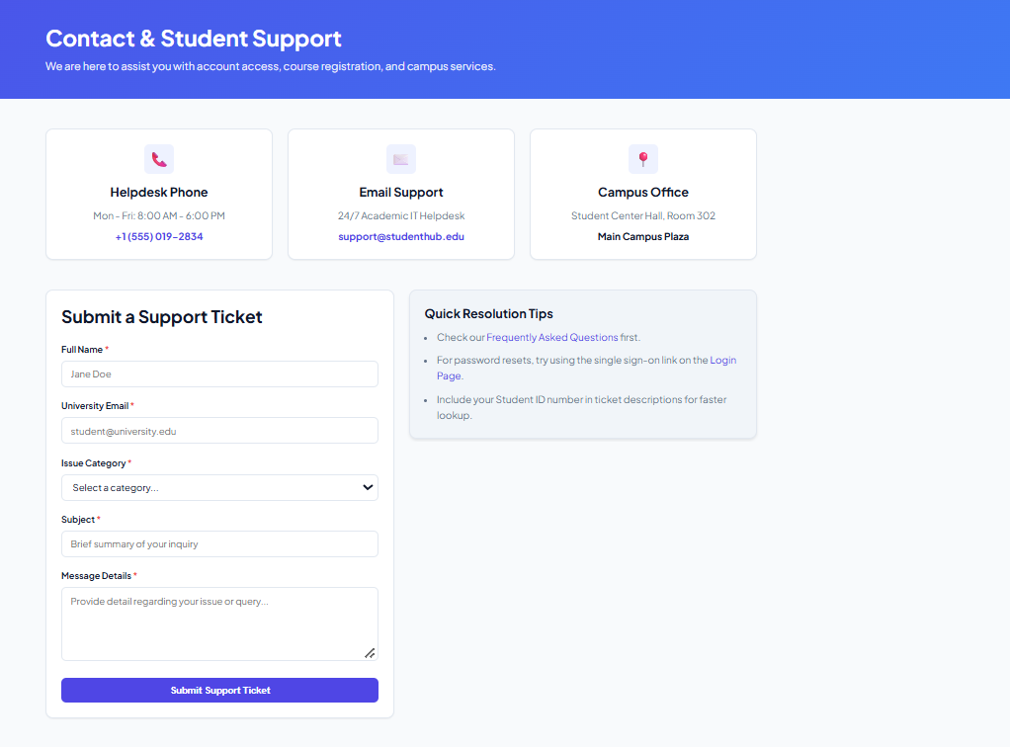

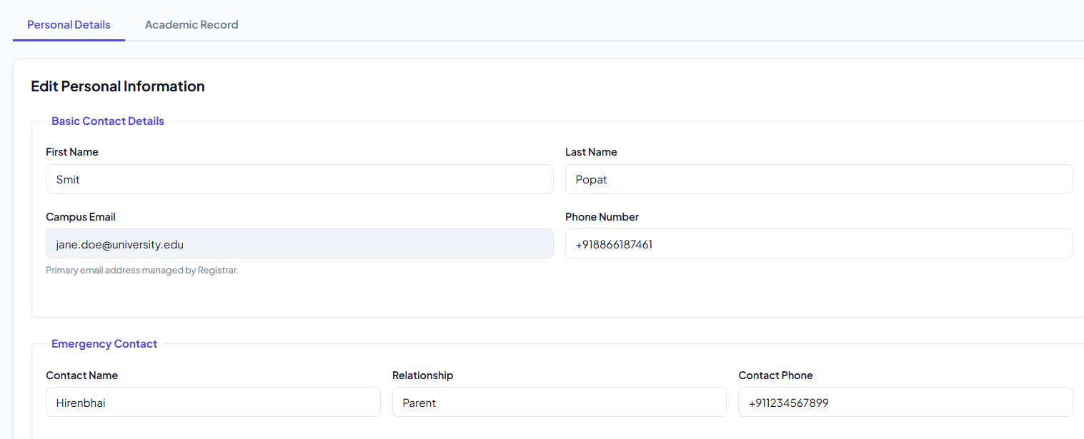
Profile Page:

Key Questions:

1. How does the layout adapt for mobile, tablet, and desktop screens?
Ans:The website uses a mobile-first responsive design approach. Media queries are used to
change the layout according to screen width.
- On mobile screens, content is displayed in a single column. Navigation links and cards are stacked vertically for easy viewing.
- On tablet screens, the layout uses two columns where suitable, such as for event cards or dashboard sections.
- On desktop screens, the layout uses multiple columns. The dashboard can include a sidebar, and cards can be displayed in rows.

2. Which layout technique is used and why?
Ans:Flexbox is used for one-dimensional layouts, such as navigation bars, buttons, headers,
and aligning items in a row or column.
CSS Grid is used for two-dimensional layouts, such as dashboard cards, event sections, and page content with rows and columns.
Flexbox and Grid make the website layout flexible, reusable, and easier to manage on different screen sizes.

3. Are typography, spacing, colors, and contrast readable?
Ans:Typography, spacing, colours, and contrast are selected to make the website clear and readable.
- Readable font sizes are used for headings and normal text.
- Proper margins and padding are added between sections, cards, buttons, and text.
- Consistent colours are used throughout the website.
- Dark text is used on light backgrounds to provide good contrast.
- Buttons have clear colours and readable text.
These design choices improve the user experience and make the interface professional.

4. Is the framework used consistently without unnecessary inline CSS?
Ans:If Bootstrap or Tailwind CSS is used, its classes are applied consistently across all pages. Common components such as navigation bars, cards, forms, buttons, and grids use the same style.
Custom CSS is written in a separate CSS file. Unnecessary inline CSS is avoided because it makes the code difficult to maintain and reuse.

GitHub Link: https://github.com/dhruv07bhanvadia/WDF/tree/main

